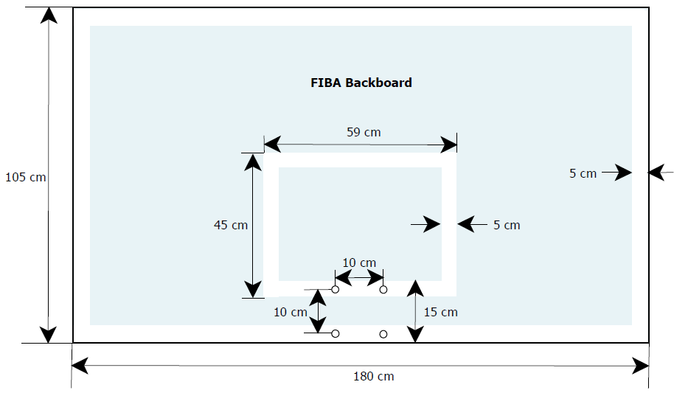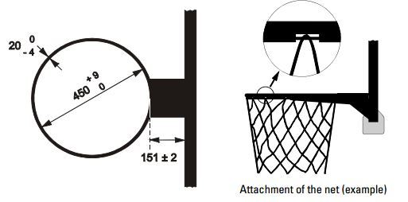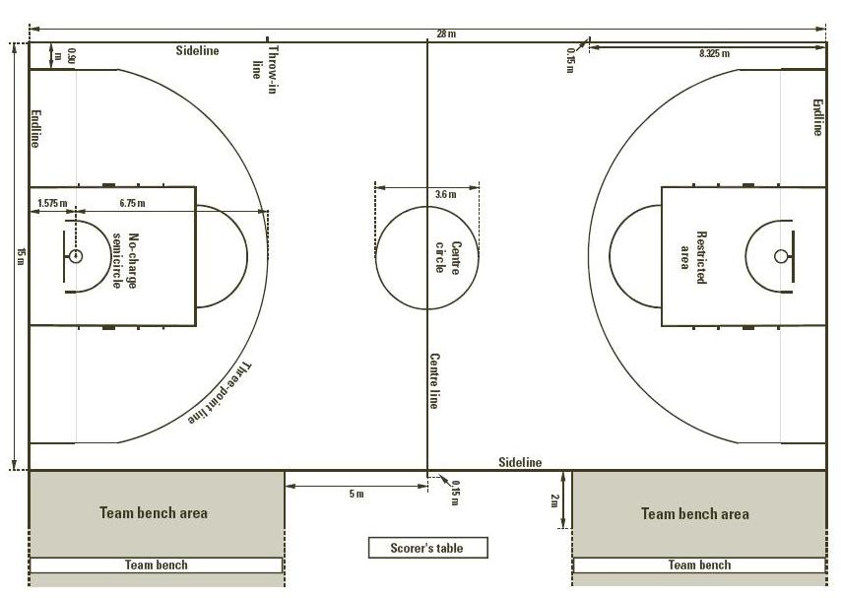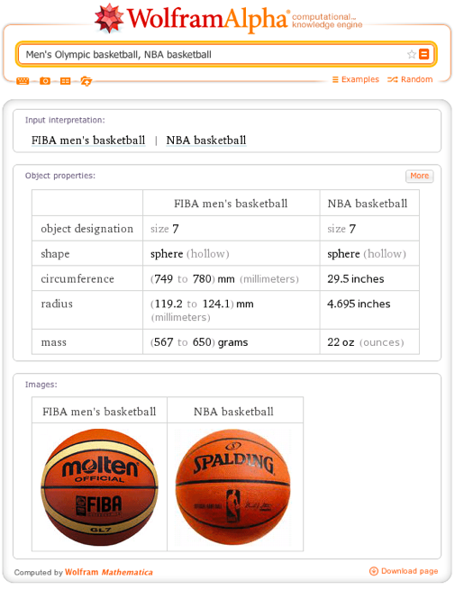

HISTORY
Dr. James Naismith in December 1891 in Springfield, Massachusetts. The first public basketball game was played in Springfield, Massachusetts, on March 11, 1892.^{[1]}

Original rules
There were only thirteen rules of "basket ball":
- The ball may be thrown in any direction with one or both hands.
- The ball may be batted in any direction with one or both hands.
- A player cannot run with the ball, the player must throw it from the spot on which he catches it, allowance to be made for a man who catches the ball when running at good speed.
- The ball must be held in or between the hands, the arms or body must not be used for holding it.
- No shouldering, holding, pushing, tripping or striking in any way the person of an opponent shall be allowed. The first infringement of this rule by any person shall count as a foul, the second shall disqualify him until the next goal is made, or if there was evident intent to injure the person, for the whole of the game, no substitute.
- A foul is striking the ball with the fist, violation of rules 3 and 4, and such as described in rule 5.
- If either side makes three consecutive fouls it shall count a goal for opponents.
- A goal shall be made when the ball is thrown or batted from grounds into the basket and stays there. If the ball rests on the edge and the opponent moves the basket it shall count as a goal.
- When the ball goes out of bounds it shall be thrown into the field and played by the person first touching it. In case of a dispute, the umpire shall throw it straight into the field. The "thrower-in" is allowed five seconds. If he holds it longer it shall go to the opponent. If any side persists in delaying the game, the umpire shall call a foul on them.
- The umpire shall be the judge of the men and shall note the fouls, and notify the referee when three consecutive fouls have been made.
- The referee shall be the judge of the ball and shall decide when the ball is in play, in-bounds, and to which side it belongs, and shall keep the time. He shall decide when a goal has been made and keep account of the goals with any other duties that are usually performed by a referee.
- The time shall be fifteen-minute halves, with five-minute rests between.
- The side making the most goals in that time shall be declared the winner. In the case of a draw, the game may, by agreement of the captains, be continued until another goal is made.^{[2]}

The first basketball game
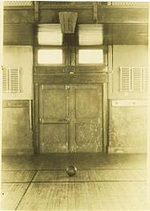
The first basketball court: Springfield College
On December 21, 1891, James Naismith published rules for a new game using five basic ideas and thirteen rules.^{[3]} That day, he asked his class to play a match in the Armory Street court: 9 versus 9, using a soccer ball and two peach baskets. Frank Mahan, one of his students, wasn’t so happy. He just said: "Harrumph. Another new game".^{[4]} However, Naismith was the inventor of the new game. Someone proposed to call it "Naismith Game", but he suggested "We have a ball and a basket: why don’t we call it basketball?"^{[5]} The eighteen players were John G. Thompson, Eugene S. Libby, Edwin P. Ruggles, William R. Chase, T. Duncan Patton, Frank Mahan, Finlay G. MacDonald, William H. Davis and Lyman Archibald, who defeated George Weller, Wilbert Carey, Ernest Hildner, Raymond Kaighn, Genzabaro Ishikawa, Benjamin S. French, Franklin Barnes, George Day and Henry Gelan 1–0.^{[6]} The goal was scored by Chase.^{[7]} There were other differences between Naismith’s first idea and the game played today. The peach baskets were closed, and balls had to be retrieved manually, until a small hole was put in the bottom of the peach basket to poke the ball out using a stick. Only in 1906 were metal hoops, nets and backboards introduced. Moreover, earlier the soccer ball was replaced by a Spalding ball, similar to the one used today.^{[8][9]}

NBA
The Basketball league was founded in New York City on June 6, 1946 as the Basketball Association of America (BAA).^{[27]} The league adopted the name National Basketball Association (NBA) in 1949 after merging with the rival National Basketball League (NBL). As of the early 21st century, the NBA is the most significant professional basketball league in the world in terms of popularity, salaries, talent, and level of competition.

"BASKETBALL FUNDAMENTALS"
1 BASKETBALL FUNDAMENTALS
SHOOTING PASSING RULES BASKETBALL FUNDAMENTALS DRIBBLING EXTRAS LAY-UP Click on titles to enter pages
2 PASSING OVERHEAD PASS CHEST PASS BASEBALL PASS BOUNCE PASS
There are four types of pass most commonly used in basketball. Click on the links below to for more information OVERHEAD PASS CHEST PASS BASEBALL PASS BOUNCE PASS BACK TO MENU PAGE
3 OVERHEAD PASS Hands in W shape on ball
Pass comes from above head, not from behind Step forward into pass Pass should travel in a straight downwards slope to the receivers chest Back to passing menu
4 BASEBALL PASS Ball in throwing hand to the side of your head
Non throwing hand pointing at target One foot forward (same as non throwing hand) Throw ball as you would a baseball, step forward and follow through with throwing hand Back to passing menu
5 CHEST PASS Hands in W shape on ball Elbows Out
Pass comes from chest to receivers chest Step forward into pass Hands end up with palms facing outwards and thumbs facing down Back to passing menu
6 BOUNCE PASS Hands in W shape on ball Elbows Out
Pass comes from chest and bounces just over ½ way between you and the receiver Step forward into pass Hands end up with palms facing outwards and thumbs facing down Back to passing menu
7 SHOOTING PICTURES Technique 1 Technique 2
Correct technique is vital in producing an effective and successful jump-shot in basketball. Click on the links below for more information PICTURES Technique 1 Technique 2 BACK TO MENU PAGE
8 Technique 1 Feet shoulder width apart facing the basket, knees should be bent Ball resting on shooting hand with non shooting hand supporting side of ball Shooting arm elbow tucked in and at a 90 degree angle (L shape) Whole body should be square to the basket Back to shooting menu
9 Technique 2 Shot power comes from the legs
Extend legs and arms and release the ball Flick your wrists for a follow through to create backspin Create a rainbow shape with the ball Jump and land on the same spot Back to shooting menu
10 Back to shooting menu
11 DRIBBLING PICTURES Technique 1 Technique 2
Dribbling is used to move from one area to another with the ball. Players must be able to dribble with both hands to be an effective basketball player. Click on the links below for more information PICTURES Technique 1 Technique 2 BACK TO MENU PAGE
12 Technique 1 Dribble the ball with your fingers and not the palm of your hand Keep your knees bent Bounce the ball no higher than waist height Keep your head up at all times Use non dribbling arm for balance Back to dribbling menu
13 Technique 2 Dribbling is used to beat defenders
The right hand is used predominantly on the right side of the court, and the left on the left side of the court Advanced dribbling skills include: Crossover dribble Spin dribble Back to dribbling menu
14 Back to dribbling menu
15 RULES POSITIONS VIOLATIONS FOULS TIMES COURT SCORING BACK TO MENU PAGE
16 POSITIONS Ten Players in a team Five on court at any one time
Substitutions can occur at any time and substituted players can return to the game Point guard (Jason Parker) Shooting guard (Alan Iverson) Small Forward (Lebron James) Power Forward (Kevin Garnet) Centre (Shaquille O’Neal) Back to rules menu
17 VIOLATIONS Double dribble – Once a player has picked up their dribble they are not allowed to dribble the ball again Travelling – When in possession of the ball, taking any steps without dribbling results in a travel Back Court – Once an attacking team has crossed the half-way line they cannot pass the ball back into their own half Back to rules menu
18 FOULS Personal foul – a foul occurring during play. Each player is allowed 5 before a sending off Technical foul – a more serious foul occurring anytime during a game. These fouls can be against anyone in the team including the coach. 2 per person are allowed before being sent off If a foul occurs in the act of shooting the attacking player is awarded free throws Back to rules menu
19 COURT Court length is 30m at professional level Court width is 15m
The baskets are 10 feet from the ground The blue area in the middle is the centre circle where tip off takes place The blue area under the basket is called the key Back to rules menu
20 SCORING Shot from inside the semi circle: 2 points
Shot from outside the semi circle: points Free Throws (foul shots): point each Back to rules menu
21 TIMES A game is 40 minutes long, divided into four 10 minute quarters
A team has 24 seconds to take a shot 8 seconds to pass the half way line 5 seconds to make a pass inbounds 3 seconds in the key area Each team has two timeouts per quarter which last for one minute each and can be used at any time Back to rules menu
22 LAY-UP FULL CLIP PHASE ONE PHASE TWO PHASE THREE PHASE FOUR PHASE FIVE
The lay-up shot entails a dribble followed by two steps towards the basket, with a jump off one foot and placing the ball in the basket. It is the highest percentage shot used in basketball. FULL CLIP PHASE ONE PHASE TWO PHASE THREE PHASE FOUR PHASE FIVE PHASE SIX PUPIL INPUT PAGE Click on titles to go to page BACK TO MAIN MENU PAGE
23 FULL LAY-UP SHOT 4 1 5 2 6 3 Click screen to play clip
Back to lay-up menu Click on a numbered picture to see the breakdown of the lay-up
24 PHASE ONE Dribble Approach Head up Ball in front of body Knees bent
Back to lay-up menu Click on picture to return to full clip
25 PHASE TWO Pick up ball Eyes on basket Cease dribble, ball held tightly
In both hands Approach should be straight and direct to the basket Click on picture to return to full clip Back to lay-up menu
26 PHASE THREE Step phase Focus on basket Ball raised to chest
After picking up ball, take two steps Click on picture to return to full clip Back to lay-up menu
27 PHASE FOUR Take off Ball raised above head
Raise knee to create power and height in the jump On right side of basket, jump off left foot Click on picture to return to full clip Back to lay-up menu
28 PHASE FIVE Release ball Release ball Extend arm towards basket
Extend body to a Straight position The higher off the floor you get, the closer to the basket you will be Click on picture to return to full clip Back to lay-up menu
29 PHASE SIX Finish lay-up Ball in top right hand corner
of small square on backboard Follow path of the ball With hand Eyes still focused on basket Non shooting arm for balance Click on picture to return to full clip Back to lay-up menu
30 PUPIL INPUT PHASE ONE PHASE TWO PHASE THREE PHASE FOUR PHASE FIVE
PHASE SIX Click on one of the pictures to view phases Back to lay-up menu
31 PHASE ONE Dribble Approach What are the teaching points In this phase?
- Look at the picture and describe how the action could be improved - Back to lay-up menu Back to pupil input menu
32 PHASE TWO Pick up ball What are the teaching points in this phase? -
Look at the picture and describe how the action could be improved - Back to lay-up menu Back to pupil input menu
33 PHASE THREE Step phase What are the teaching points In this phase? -
Look at the picture and describe how the action could be improved - Back to lay-up menu Back to pupil input menu
34 PHASE FOUR Take off What are the teaching points In this phase? -
Look at the picture and describe how the action could be improved - Back to pupil input menu Back to lay-up menu
35 PHASE FIVE Release ball What are the teaching points In this phase? -
Look at the picture and describe how the action could be improved - Back to pupil input menu Back to lay-up menu
36 PHASE SIX Finish lay-up What are the teaching points I this phase -
Look at the picture and describe how the action could be improved - Back to pupil input menu Back to lay-up menu
37 EXTRAS LINKS TO THE WEB MOVIE CLIPS BACK TO MENU PAGE
Click on the titles above to access the pages
38 MOVIE CLIPS Back to extras menu
Click on the video images to view movies
39 LINKS TO THE WEB BETTER BASKETBALL ENGLAND BASKET STREETBALL WALES NBA
LET ME PLAY BASKETBALL DRILLS AND PLAYS HOW TO PLAY ESSEX BASKETBALL Click on the titles above to access the internet and find out more about basketball Back to extras menu

